1  2  3  4  5  6  7  8  9  10  11  12  13  14  15  16  17  18  19  20 | STURMINSTER MARSHALL PARISH COUNCIL  Minutes of the Annual Meeting of the Full Council on Thursday 1st May 2025 at 7.30pm at the Memorial Hall  Present: Chair Cllr S Cade, Cllr H Palmer, Cllr M Steel, Cllr H Fookes, Cllr Jones, Cllr J Jackson and Cllr L Seare  Also in attendance: Mrs A Clothier (Parish Clerk),  Election OF CHAIR  Cllr Seare nominated Cllr Cade for the position of Chair. This nomination was seconded by Cllr Fookes and unanimously approved.  ELECTION OF VICE CHAIR  Cllr Steel proposed Cllr Palmer for Vice Chair. This was seconded by Cllr Jones and unanimously agreed.  DECLARATION OF ACCEPTANCE OF OFFICE  The Declarations of Acceptance of Office was duly signed.  Apologies – Members of the Council.  Apologies were received and accepted from Cllr L Purtill and Dorset Councillor W Chakawhata.  dECLARations of interest  There were none.  MEMBERS OF PUBLIC –  There were no members of the public present.  APPOINTMENT OF COUNCIL OFFICERS AND WORKING PARTIES  See Appendix 1.  INSPECT DEEDS AND INSTRUMENTS  The Council reviewed two licences:  - Churchill Close Green (annual licence)  - The Pound (licence valid until 2027)  - Memorial Hall Lease with Solicitor  General power of competance  It was confirmed that the Clerk holds the CiLCA qualification and that two-thirds of the Council members are elected, meeting the criteria for the General Power of Competence. The General Power of Competence remains in place.  POLICE REPORT  The Police will be attending the Open Meeting in May. The Clerk received an email from UKPAC to check on the situation in Sturminster Marshall.  MINUTES  The minutes of the Full Council Meeting held on 3rd April 2025 were approved as true record of the meeting.  MATTERS ARISING  A report from the Clerk which had been circulated and is attached to these minutes as Appendix 2. Ongoing issues from the Clerks Report are:  - Memorial Hall Registration  - EV Charge Point  AMENITIES AND FACILITIES  - Playground – General condition is satisfactory. Maintenance noted: ropes on the witch’s hat inspected; bird’s nest swing requires lowering; an inverted bar remains where the old bin was located; the wheelie bin is unsecured. A formal inspection is due in June. The see-saw base needs softening and tightening.  - Churchill Close Green – The licence has been passed to the Football Club for signing. Wording unchanged from the previous year.  - Refurbishment of benches and noticeboard – Bench work completed. The electricity box key has been located. Cllr Jones to inspect the connection. Three litter signs have been installed, with two more planned for Station Road and High Street.  - Trees and Maypole – A quote has been received for tree work. Clerk to request a comparison quote from an alternative contractor. A quote for Maypole powder coating has been accepted at £150 plus VAT. Discussion held on Maypole height: the original was 32 feet; 25 feet was agreed as a suitable replacement height.  Action: Cllr Jones to explore options and pricing for a new Maypole.  - Memorial Hall – The Memorial Hall Committee agreed to the draft deed of variation, with the exception of updating Trustee names. The matter is now with the solicitor.  - Silent Soldier – The gardening group cannot carry out the required maintenance. A tree near the site needs pruning. The Parish Council will explore the purchase of poppy seeds.  ENVIRONMENT  - Climate Change Action Plan –  EV Charge Point – Phase I of the work on the EV charge point is scheduled to begin on 19th May. The Hall Committee have been informed.  TRAFFIC & TRANSPORT  i A31/A350 – the following points were discussed. Noted road closures, including A31 and those around Maypole Green on 5th May. A new school sign will be installed near Bailie Gate Roundabout. The stopping of the highway was allowed at the Churchill Arms site.  - Speeding on Mill Lane – the Parish Council have been made aware of new Please Slow Down signs that were successfully trialled by Dorset Police and Crime Commissioner.  Action: Clerk to contact Dorset Road Safety Team to see if the signs are suitable for Mill Lane and Newton Road.  REPORTS  To receive reports from representatives of the following:  i Alms House Charity – nothing to report  ii Memorial Hall – the AGM is on 3rd June and the new Chair and Secretary will take over. The renovations are on hold due to finances.  iii DAPTC – New Deputy Chief Executive (Will Austin) and Training Officer (Brie Logan) appointed. Guidance on registering and disclosing interests was reviewed.  iv. Flood Wardens – nothing to report  v. School – The Headteacher is currently absent. Mrs Bentley has taken on additional leadership responsibilities and is supported one day a week by a headteacher from another local school that has similar circumstances with mixed age class teaching.  There have been applications for the governor positions  vi. Speedwatch – next session on 16th May at Railway Drive  vii Dorset Councillor – no report.  FINANCE  - Accounts for payment. To receive invoices and approve payments as per Schedule of payments. See Appendix 3. It was RESOLVED to APPROVE the payments with all in agreement.  - To receive the monthly bank reconciliation, and budget report – all noted and agreed. A move to a receipts and payments system is under consideration.  - To discuss moving to Microsoft 365 business – Approved: Clerk’s subscription at £115.20/year; Councillor Basic accounts at £19.99/year.  - To confirm the renewal of the Parish Council Insurance – Clear Councils policy renewed with Ecclesiastical as part of a 3-year agreement. Approved.  - To confirm payment of Data Protection Fee – Payment confirmed and approved.  - To discuss payment of community bus grant for 2024/25 and 2025/26 – Approved grant of £1,500 for 2024/25. Figures for 2025/26 pending.  - To acknowledge payment of CIL monies - £11,199 received. Must be spent within five years. Councillors to propose suitable infrastructure projects.  - To ratify uplift in SID deployment fee – A 5% increase in the fee was ratified.  - To review the Action Plan for 2025/26 – Reviewed and approved (Appendix 4).  POLICIES  - To adopt Standing Orders – deferred to June meeting  - To adopt Financial Regulations – deferred to June meeting  CORRESPONDENCE  DAPTC Star Award – One-star award received.  Resident Engagement Project Regarding Social Housing under occupancy – Posters displayed on noticeboards.  Town and Larger Parishes Meeting with Dorset Council – Clerk to attend.  PARISH MATTERS  - Memorial Bench Policy – Query raised.  - Parish Council Open Meeting – Upcoming.  - Air Ambulance Clothing Bank – Overflow reported.  - Code of Conduct Training – Noted.  Open Meeting Thursday 22nd May 2025 7.30 pm  The Parish Council meeting was suspended at 9.01pm whilst the Planning Committee took place. See minutes 1st May 2025 for details.  The Parish meeting re-convened at 9.28pm  DATE AND TIME OF NEXT MEETING – Thursday 5th June 2025 at 7.30pm  There being no other business the meeting closed at 21.28  Signed ____________________________________Chairman 5th June 2025

STURMINSTER MARSHALL PARISH COUNCIL - REPRESENTATIVES
Committee/Organisation/Subject | Representative(s)
Planning Committee (7) | Chair: Cllr H Fookes  ViceChair: L Seare  Members: Cllrs:  H Palmer  M Steel  L Purtill  J Jackson  S Cade  D Jones
Memorial Hall | Cllr M Steel
DAPTC | Cllr M Steel  Cllr S Cade
Utilities | Cllr D Jones
Tree & Rights of Way | Cllr J Jackson  Cllr L Seare
Sport | VACANT
Transport | Cllr J Jackson  Cllr M Steel
Ancient Monuments/Archives | Cllr H Palmer
Emergency Representative Liaison | Clerk Mrs A Clothier  Cllr S Cade  Cllr H Palmer  Cllr D Jones
Community School Governor | Cllr H Fookes
Alms House Charity | Cllr L Purtill
Play Area Maintenance | Cllr M Steel  Cllr J Jackson
Responsible Finance Officer | Mrs Alison Clothier (Clerk)
Finance and Staffing Working Party | Cllr H Palmer  Cllr L Purtill  Cllr S Cade  Cllr L Seare
Flood Warden | Cllr H Fookes  Cllr D Jones  Mrs Alison Clothier (Clerk)
Website/Social Media | Mrs Alison Clothier (Clerk)  Cllr M Steel  Cllr L Purtill
Youth | Cllr M Steel
Neighbourhood Plan Steering Group | Mr J Quick (Chair)  Mr R Daniels (Vice Chair)  Cllr H Palmer  Cllr S Cade  Cllr H Fookes  Cllr M Steel  Mrs A Clothier (Clerk)
Climate Change | Cllr J Jackson  Cllr H Palmer
Health | Cllr L Purtill

Clerks Report 01.05.25
Minute Number | Topic | Action | Progress
18th July 2024 Minute 7 (i) | Play Area | Repair of playground equipment | The contractor will treat the timber on the birds nest swing.
18th July 2024 Minute 8 (ii) | EV Charge Point | Progress registration of Memorial Hall  Progress EV Charge Point near Air Ambulance Recycling | The draft lease is with the Memorial Hall Management Committee  Licence agreement signed off by all parties. Waiting to hear when SSEN can make the connection to the electricity grid which will do into a feeder pillar. The textile bin will be moved to accommodate the charger.
5th September Minute 16 | Correspondence | Clerk to ask Dorset Council for a new litter bin at Cliff Arch | Ongoing – this is being monitored by Dorset Council
3rd October Minute 10 iii | Reports | Clerk to investigate Microsoft 365 | Two quotes have been received. There is also the option of buying directly from Microsoft which would be a cheaper alternative.
3rd October Minute 14 | Parish Matters | Clerk to write to Rob Smith at Aster about replanting trees | An email to Aster has been sent and acknowledged but no response given.  A second email has been sent and acknowledged.
5th December  Minute 10 | Traffic and Transport | Clerk to chase the progress on a flooding on A350 | This has been investigated and no fault found. Item closed.
9th January Minute 8 (iv) | Environment | Clerk to query Mapperton Ditch with Community Highways Officer | This is on the highways works list of jobs
9th January Minute 9 (ii) | Traffic and Transport | Clerk to arrange meeting about speeding on Mill Lane | Slow signs to be painted in the road and village gateway sign to be moved towards the bridge.
3rd April Minute 7 | Amenities | Clerk to ask per permission to site litter signs | Emails sent to Dorset Council. Permission refused for outside Premier as already too many signs on the lamppost. Perhaps sought for two different lampposts on Station Road.
3rd April Minute 7 | Amenities | Clerk to contact Dorset Council to ask for permission to tidy up area opposite the war memorial. | The boundary is the old hedge line, in front of the wooden fence. Any clearance works can be carried out up to that line.  Permitted for remembrance soldiers to be put up, so long as they do not affect sight lines.  Wild flower seeds requested from Dorset Council
Other |  |  | Preparation for internal audit  Enforcement – Churchill Arms delivery times

Training Completed

Upcoming Training

Schedule of Payments

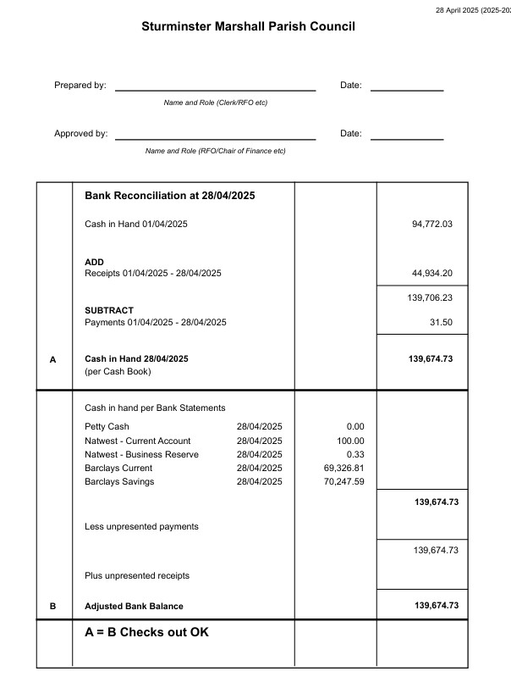

Sturminster Marshall Parish Council Action Plan 2025-26

Sturminster Marshall Parish Council will publish an action plan annually in April. The Plan will be drawn from the budget which is set in December and which includes project expenditure for the forthcoming year. Sturminster Marshall Parish Council will continually review the action plan, and will add any matters as required through the year. The Action Plan will be formally reviewed by Council on a quarterly basis, to include an update on the matters identified; addition of any further appropriate actions identified during the quarter; and signing off of any completed actions. Sturminster Marshall Parish Council’s objectives for 2025-26 are:
Action | Timescale | Budget | Update
Short term Actions
Undertake survey of trees and undertake recommended works. | By Summer 2025 | £2,500
To support the community bus service | Ongoing | £1,500 | Review annually
Management of Village Greens/Common Land | Ongoing – Greenscape Countryside Ltd. | Churchill Close Green Cut: £2375 p/a  Verges: £460p/a
Management of Churchill Close Green | Churchill Close Green licence with Football Club | Churchill Close Green Cut: £2375 p/a  Verges: £460p/a
Extra cut of Verges | October 2025 | Churchill Close Green Cut: £2375 p/a  Verges: £460p/a
Replacement of Village Maypole | By May 2026 | £660 | The Maypole has been cut down at the top and needs a full replacement
Replacement Defibrillator at Memorial Hall | By May 2027 | £2500 | The defibrillator at the Memorial Hall was installed in 2017 and should be replaced every 10 years.
Register Memorial Hall with Land Registry | By Autumn 2025 | Solicitors Fees: £1800
Medium/Long Term Actions
Neighbourhood Plan | - | £6,000 | Neighbourhood Plan adopted. Review to be looked at after the Dorset Local Plan consultation emerges.
Climate Change Action Plan | Explore renewable energy options with Memorial Hall  Install Electric Car Charge Point  Autumn 2025 | Grant funding | EV Charge Point due to be installed Spring 2025
20 mph zones | Community Speedwatch up and running | Monitor | Parish Council to decide whether to pursue 20mph application.
Review speeding and junction safety at Jubilee Cross | Summer 2025 | - | Meeting to be arranged with Lytchett Matravers Parish Council to discuss
To pursue Parish Council Bronze Award | September 2025 | £200 | Evidence being gathered for application. Awaiting outcome of Audit.
Artwork on Bailie Gate Roundabout | To explore putting a sculpture on Bailie Gate roundabout | Spring 2025
On going Actions
To maintain two defibrillators | On going | £260 per year | Cllr Steel and Cllr Seare completing monthly checks.
Maintain Parish Council website and Village History website | On going | £500 | Clerk to ensure website is kept up to date  Clerk to ensure that new Accessibility Regulations are met.
Undertake increasing responsibility for highways works. | Ongoing. | £5000 | Gullying and white lines to be investigated.
Tackle issues with dog fouling within the Parish | On going | £0 | Councillors to keep a watching brief on issues and dog warden to be alerted to any problems
Maintain village benches | Ongoing | £1500 | Refurbishment of benches ongoing
Maintain high involvement in planning issues | On going | £0 | Parish Council to stay involved in planning consultations.
Produce appropriate training programme for Clerk and Councillors. | On going | £500 | New training opportunities being investigated.
Under take an annual litter pick | By April 2025 | £0
To maintain a robust and accountable financial records | By April 2025 | £900 for internal and external audit | Quarterly reports discussed by Parish Council throughout the year.
Undertake annual inspections of playground | By June 2025 | £130 annual inspection | Annual inspection booked for June

